|  |  |  |  |
| --- | --- | --- | --- |
| Medication (1) | | Medication (7) | |
| For which condition | | For which condition | |
| Dosage | Frequency of dose | Dosage | Frequency of dose |
| Medication (2) | | Medication (8) | |
| For which condition | | For which condition | |
| Dosage | Frequency of dose | Dosage | Frequency of dose |

Fold

|  |  |  |  |
| --- | --- | --- | --- |
| Medication (3) | | Medication (9) | |
| For which condition | | For which condition | |
| Dosage | Frequency of dose | Dosage | Frequency of dose |
| Medication (4) | | Medication(10) | |
| For which condition | | For which condition | |
| Dosage | Frequency of dose | Dosage | Frequency of dose |

Fold

Any additional information:

Date completed: / / Date updated: / /   
Date updated: / / Date updated: / /

Date updated: / / Date updated: / /

Date updated:

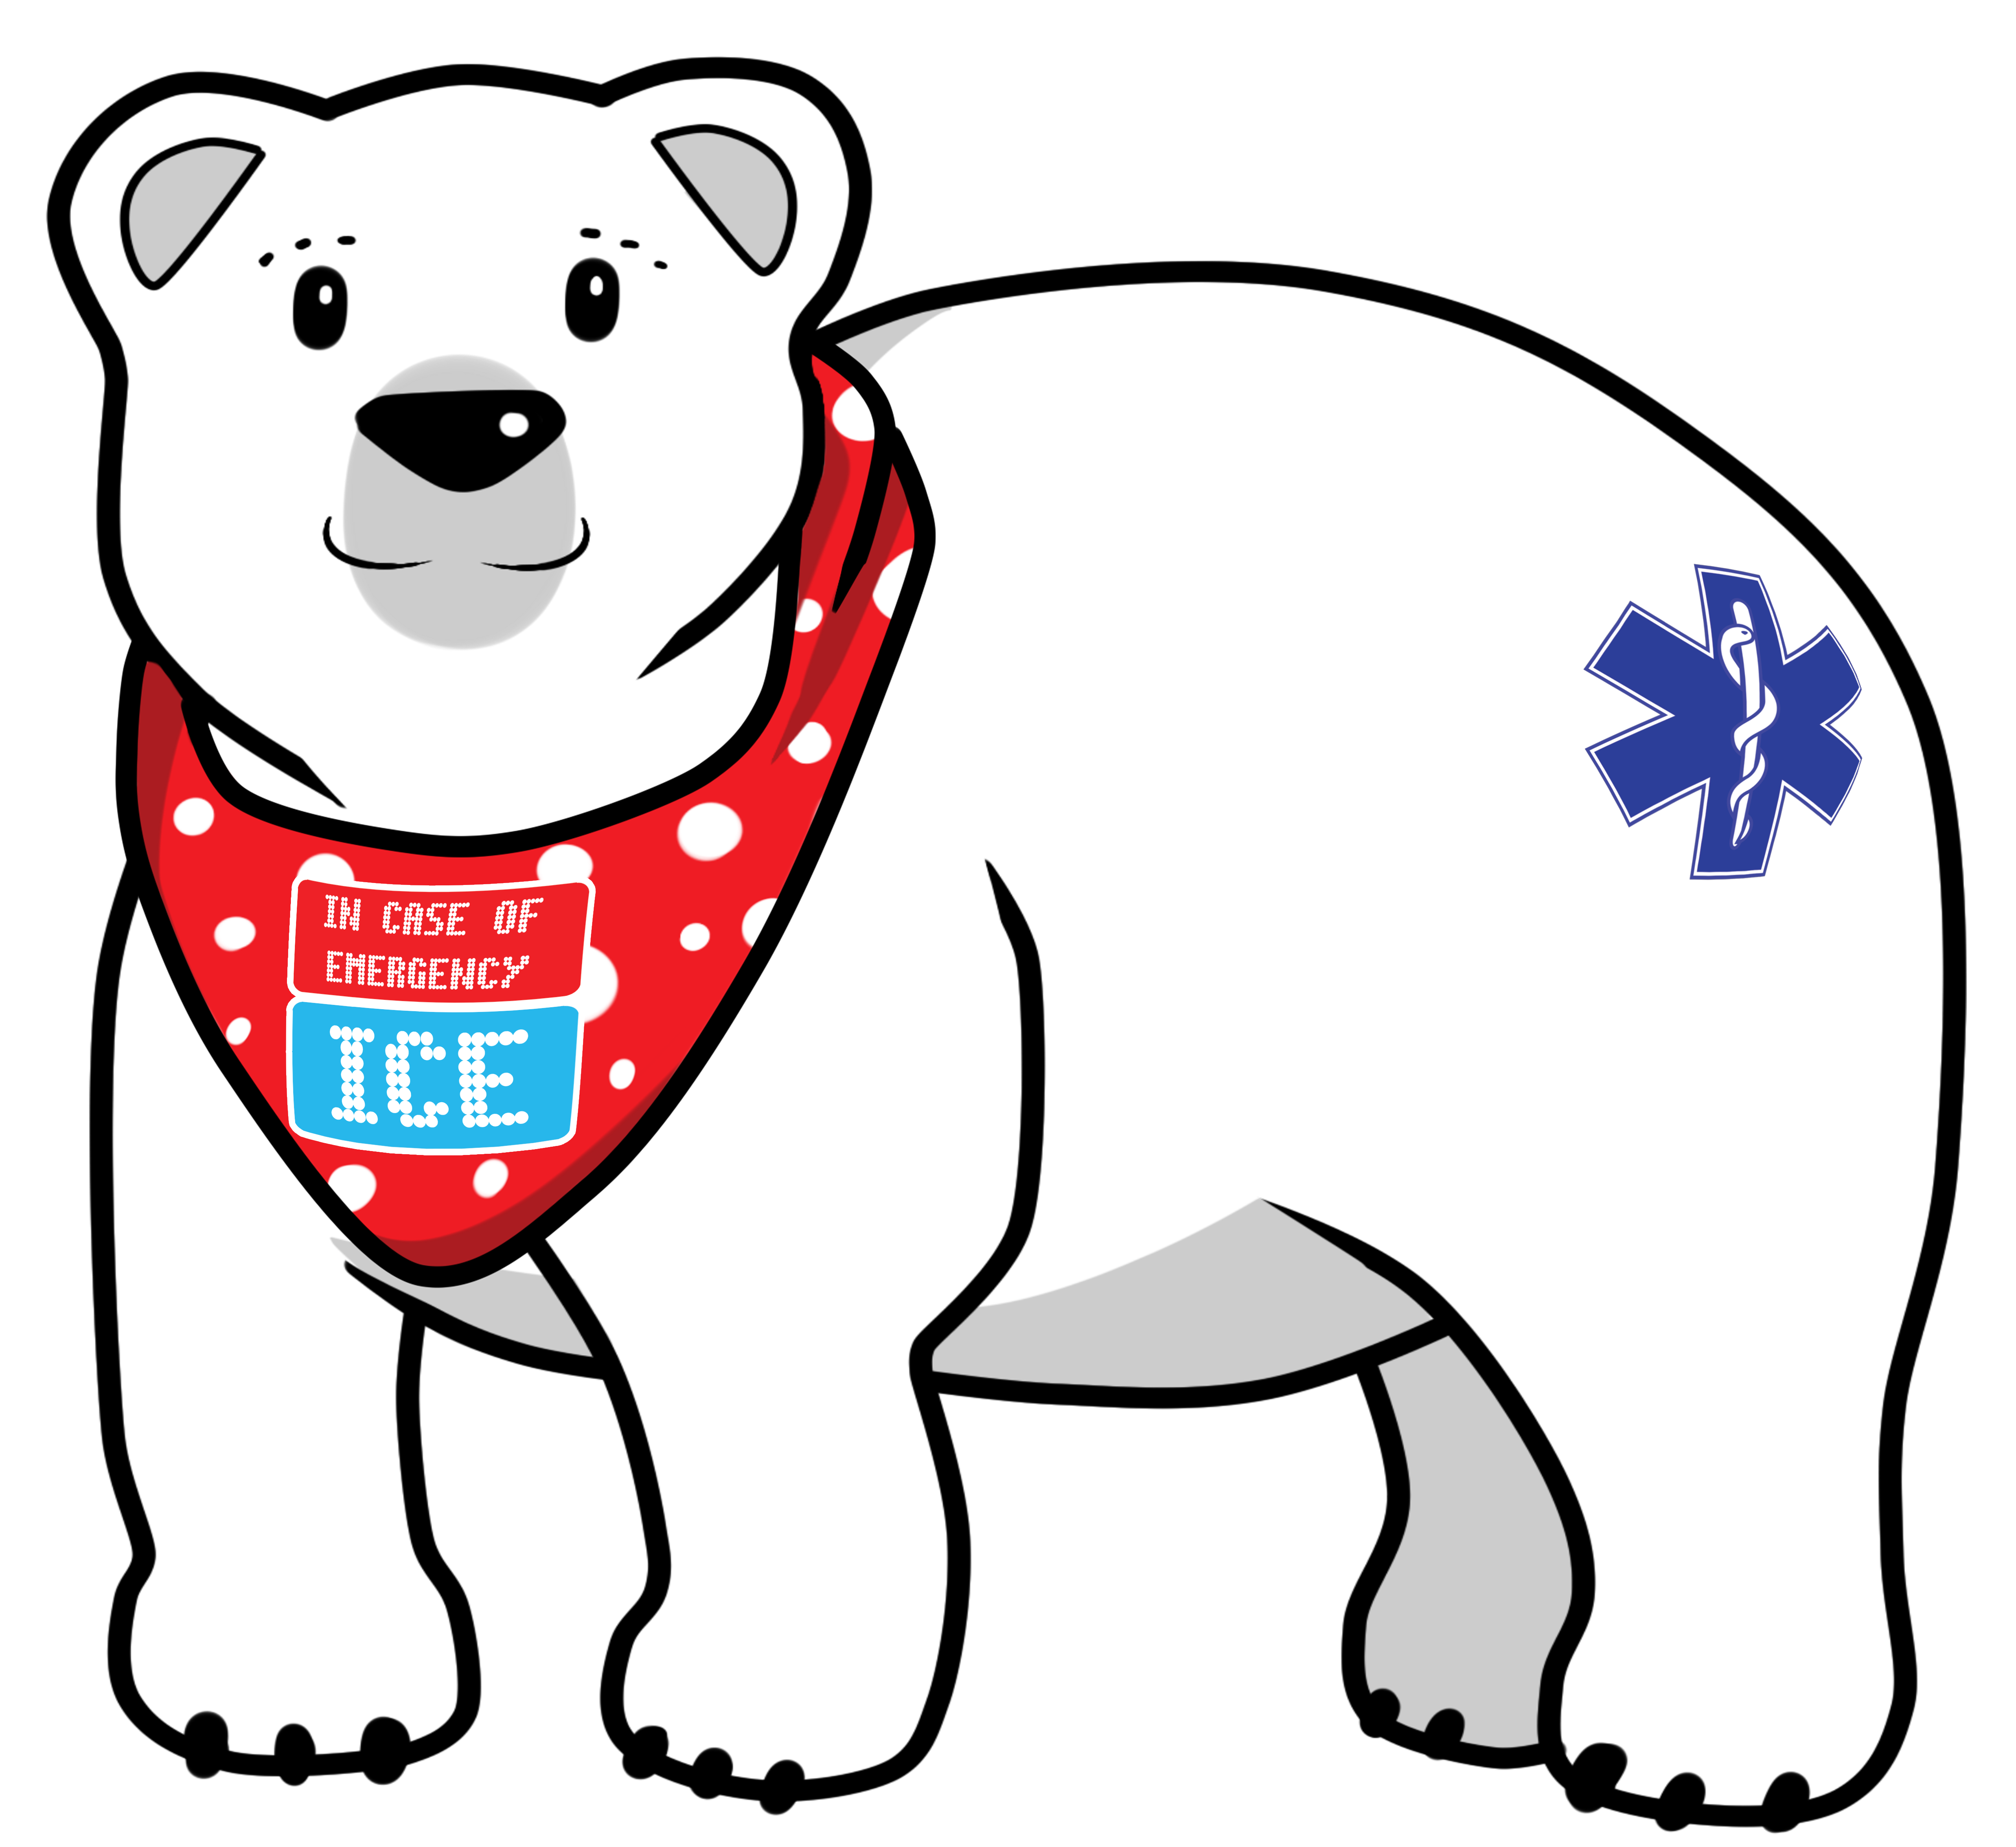

|  |  |
| --- | --- |
| Pet Home Alone If I become hurt or injured, I have an animal/animals at home that require care in my absence | |
|  | |
| Please contact this person to arrange care for my pet/pets | |
| First name | Phone number |
|  |  |
|  |  |

Fold



|  |  |  |
| --- | --- | --- |
| Medication (5) | | Any additional information: |
| For which condition | |
| Dosage | Frequency of dose |
| Medication (6) | |
| For which condition | |
| Dosage | Frequency of dose |

Fold

*This form has been designed by patients

**If you are worried or think a medical situation is life-threatening or an emergency, don’t hesitate to call 999.**



Adding ICE (In Case of Emergency) to your mobile phone allows paramedics on the scene to identify you, treat you and be able to contact your next of kin immediately.



|  |
| --- |
| Recent operations |
|  |
|  |
| Past medical history |
|  |
|  |
|  |

|  |  |
| --- | --- |
| Home  phone |  |
| Work phone |  |
| Mobile |  |
| Hospital number |  |
| (Hospital) |  |
| Hospital number |  |
| (Hospital) |  |

|  |  |  |  |
| --- | --- | --- | --- |
| GP Name |  | | |
| Address line 1 |  | | |
| line 2 |  | | |
| line 3 |  | Postcode |  |
| Phone |  | | |
| NHS Organ Donation register – Yes / No | | | |
| Willingness to have a blood transfusion – Yes / No | | | |

|  |  |  |  |  |  |  |
| --- | --- | --- | --- | --- | --- | --- |
| Emergency Contact (2) | | | Relationship | | |  |
| Title |  | Surname |  | | | |
| Forename | |  | | | | |
| Address line 1 | |  | | | | |
| line 2 | |  | | | | |
| line 3 | |  | | Postcode |  | |
| Phone  number | |  | | | | |

|  |  |  |  |  |  |  |
| --- | --- | --- | --- | --- | --- | --- |
| Emergency Contact (1) | | | Relationship | |  | |
| Title |  | Surname |  | | | |
| Forename | |  | | | | |
| Address line 1 | |  | | | | |
| line 2 | |  | | | | |
| line 3 | |  | | Postcode | |  |
| Phone  number | |  | | | | |

|  |  |  |  |  |  |
| --- | --- | --- | --- | --- | --- |
| Title |  | Surname |  | | |
| Forename/ forenames | |  | | | |
| Dob | |  | | NHS  number |  |
| Address line 1 | |  | | | |
| line 2 | |  | | | |
| Line 3 | |  | | Postcode |  |
| Email | |  | | | |

**My Personal Health Record**

|  |
| --- |
| Registered disabled  Yes / No |
| Registered blind  Yes / No |
| Sensory impairments: i.e. hearing(hearing aids), sight (spectacles or contact lenses) |
| Speech or language impairment |

|  |  |
| --- | --- |
| Religion |  |
| First language |  |
| Other languages |  |
| Current medical conditions | |
|  | |
|  | |
|  | |

|  |  |
| --- | --- |
| Special Warnings | |
| Medication / Condition | Special precautions |
| Warfarin, Steroids. Diabetic, Asthmatic, Epileptic, Osteoporotic, Other  (circle any that apply) |  |
| Allergies including drug allergies, food intolerances, latex etc. |  |
| Mobility level – Independent with no aids or assistance, unsteady, walks with aids, wheelchair user, chair bound, bed fast, needs mechanical assistance (e.g. hoisting), other  (circle any that apply) | |